**CRUD App With Image Upload Using NodeJs, ExpressJs, MongoDB & EJS Templating Engine**

<https://www.youtube.com/watch?v=zBTPDAh8ABM&list=PL6u82dzQtlfvJoAWdyf5mUxPQRnNKCMGt&index=2>

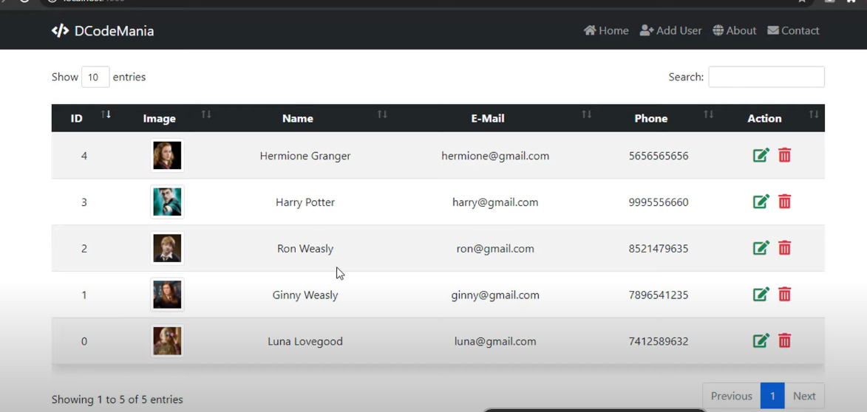

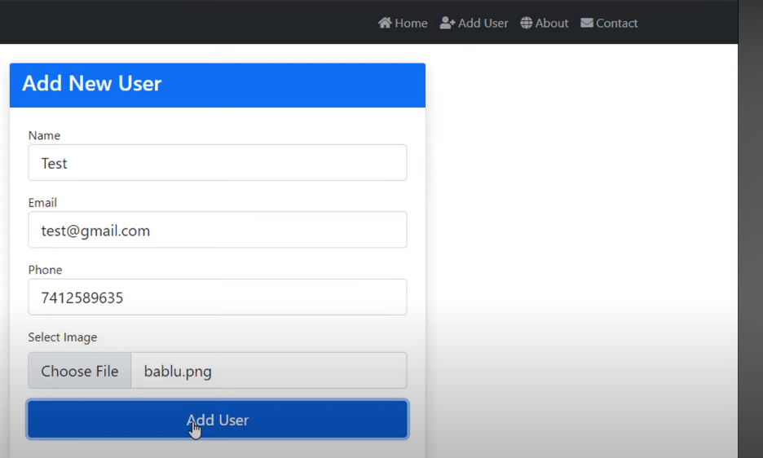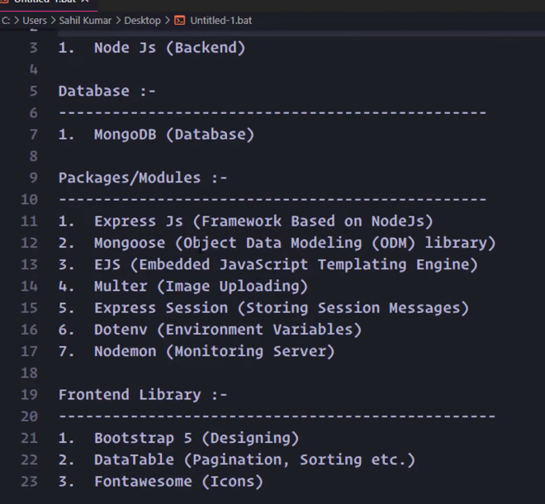

>> generate json package npm init

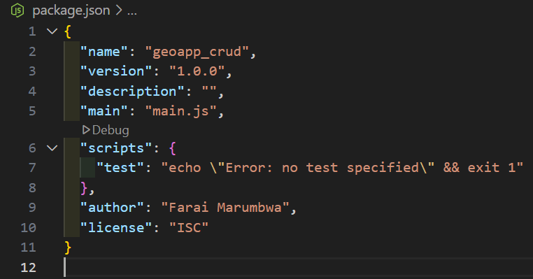

Install packages



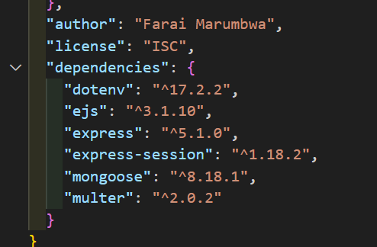

Download nodemon for dev purposes



>> Configure the start script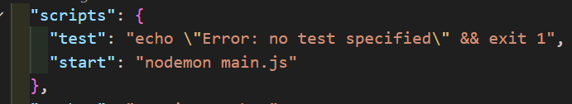

Create main.js and .env

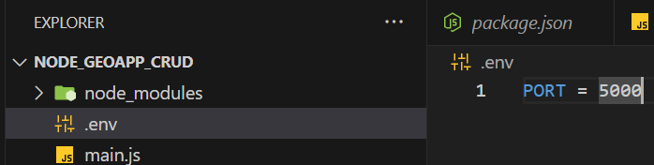

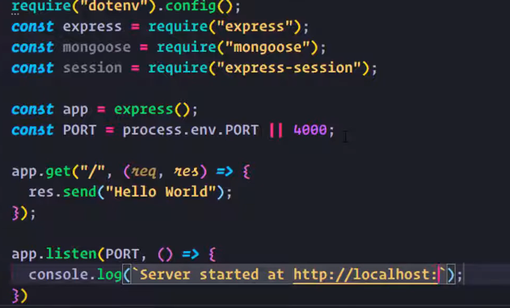 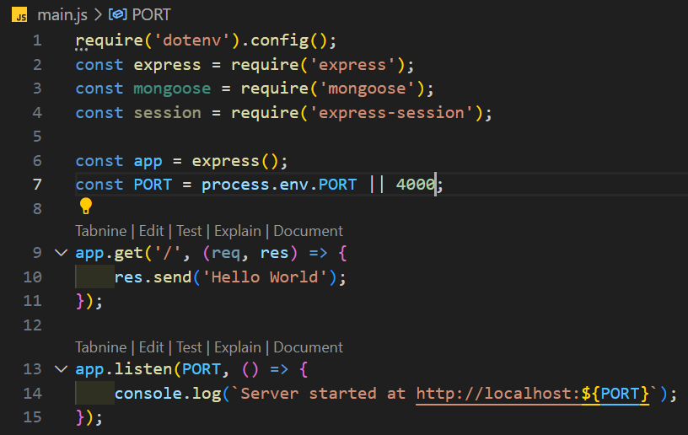

Npm start to run the script 

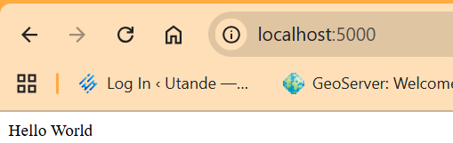

**Set up mongo database**

>> download community server & compass

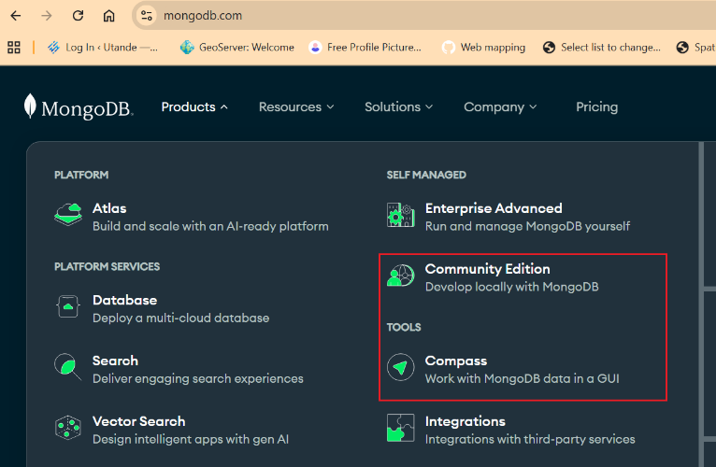

For community server ---select the defaults

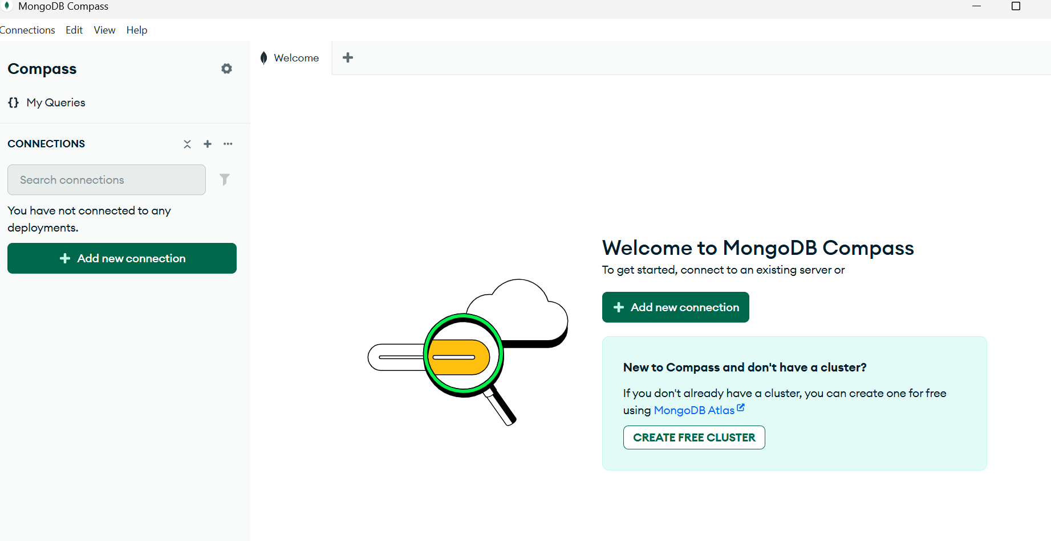

Create a new connection >> select connect >> create new database

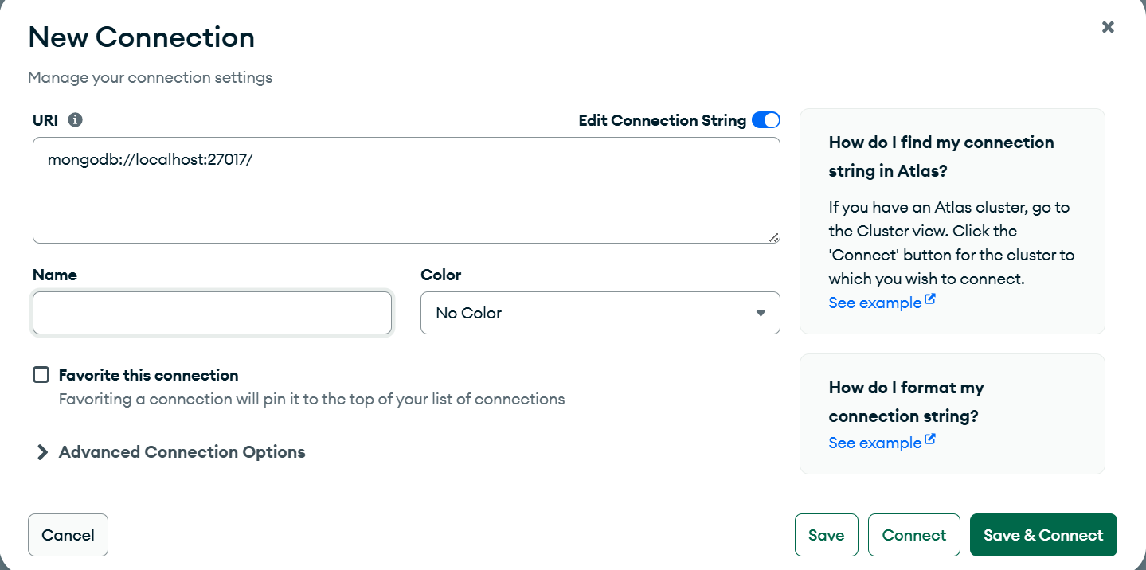

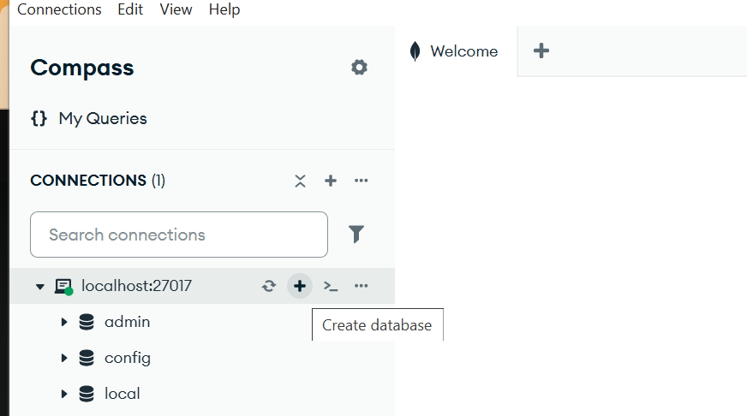 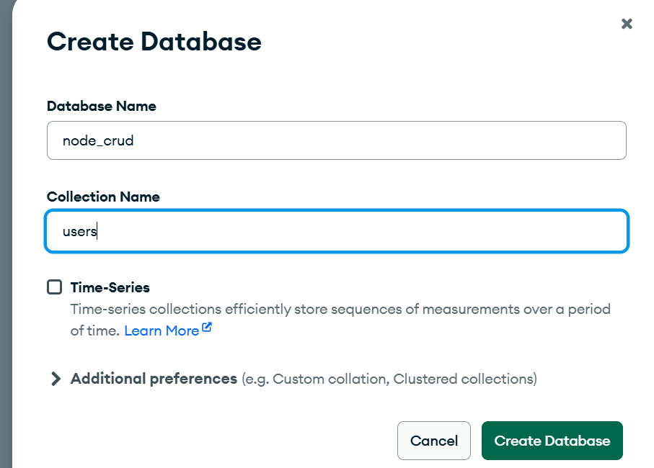

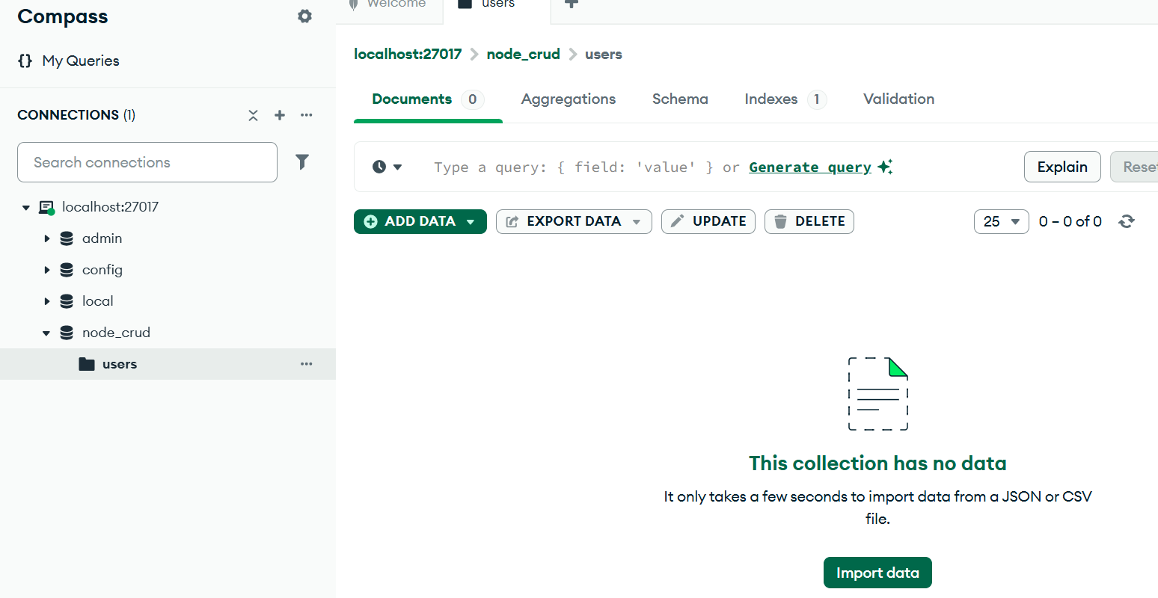

Enter the db url in the .env found on top of node 

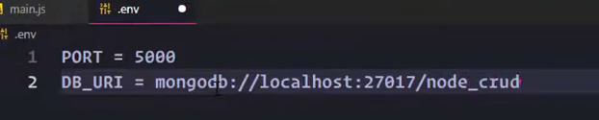

Create a db connection

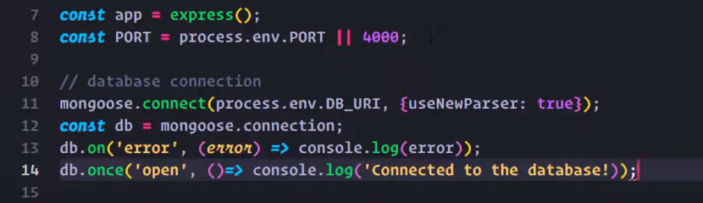

If u are getting deprecation warning >>use selected text to get rid of them

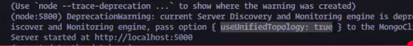

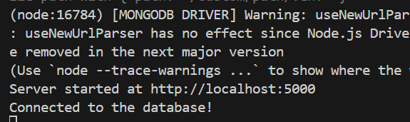

Add and initialize middleware

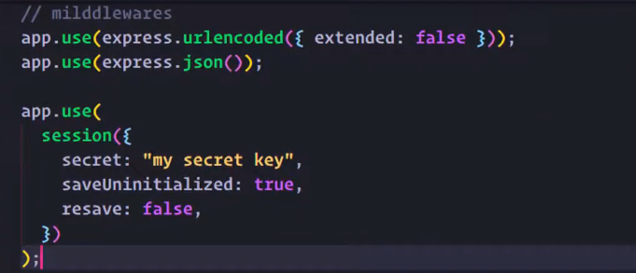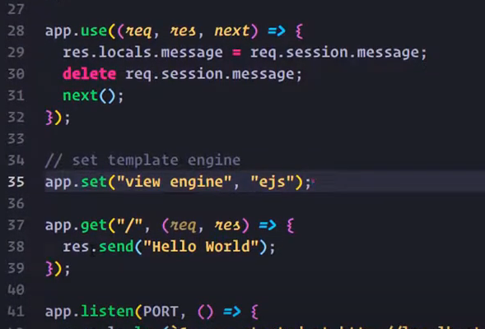

>> create folder for routes and models for holding schema

 

Create db schema

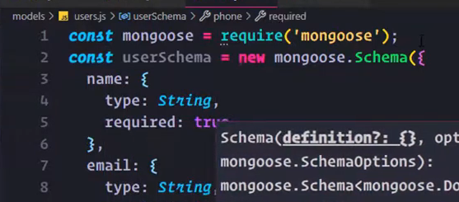 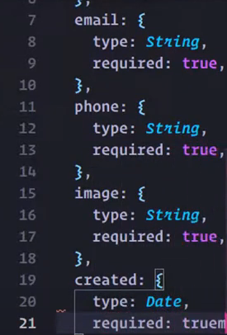

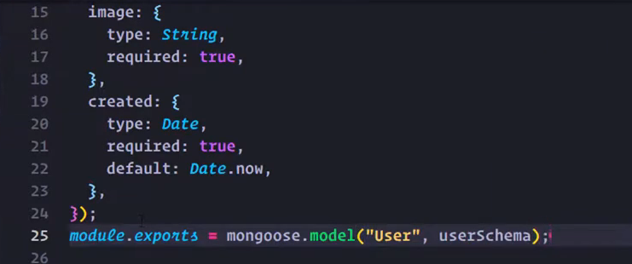

Now model ready to use

>> go to routes create a router with express and export it

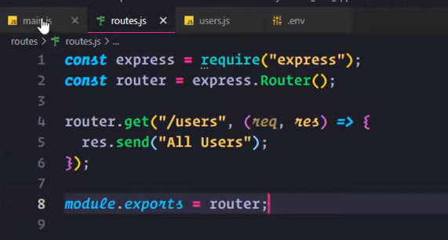

>>main.js- replace the hello router >> use middleware to call routes.js

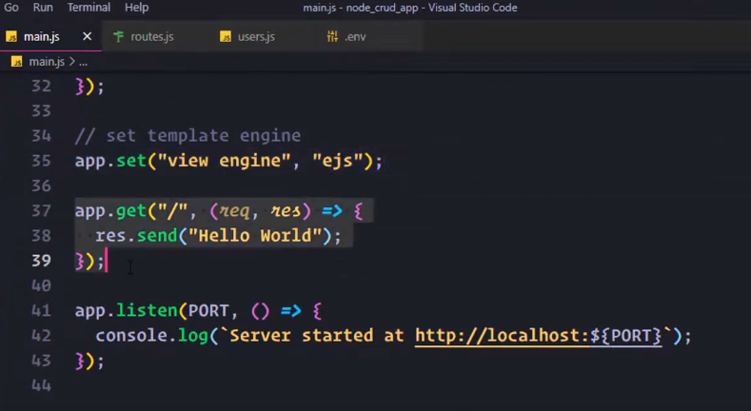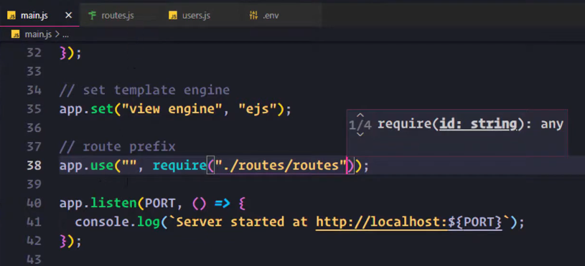

Type in the user end point

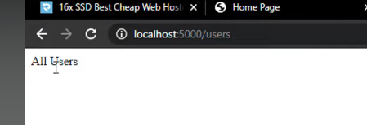

>> now write all route in the routes.js

Develop a home route

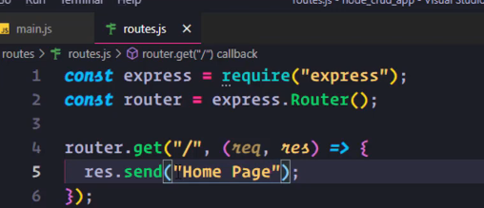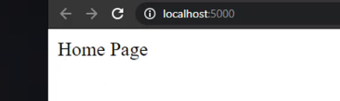

Create views dir to host ejs files for diff routes 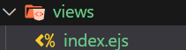

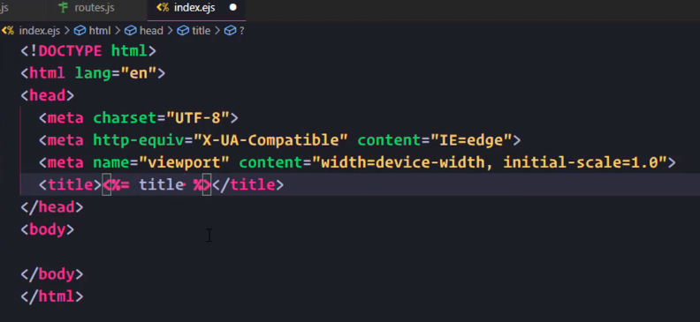

Render the file in routes u can pass in a var

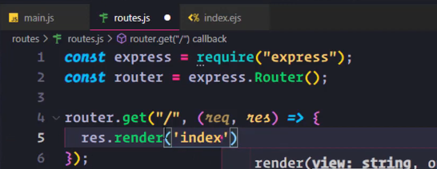 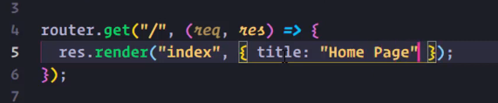

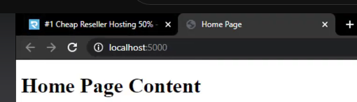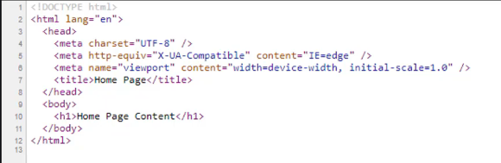

Add botstrpa

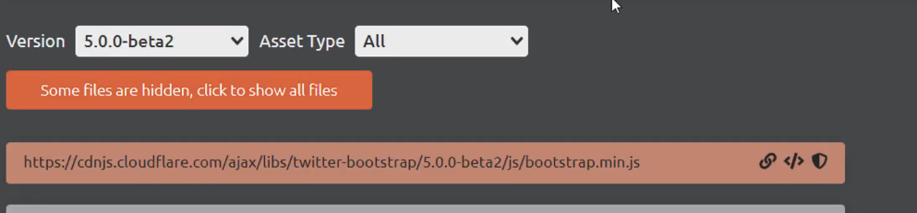

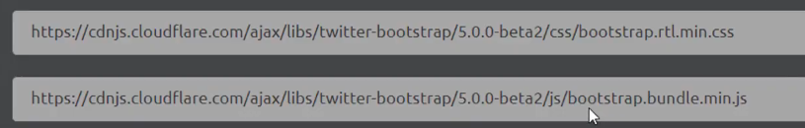

Add navbar code

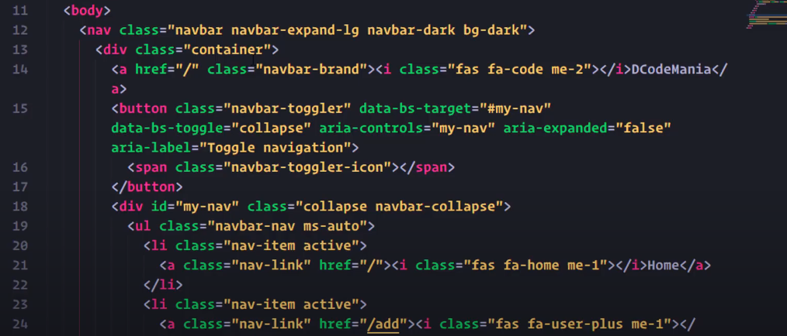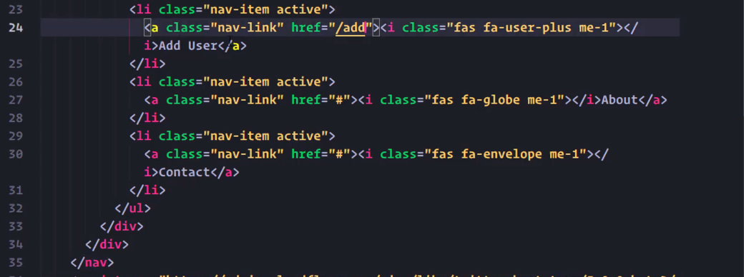

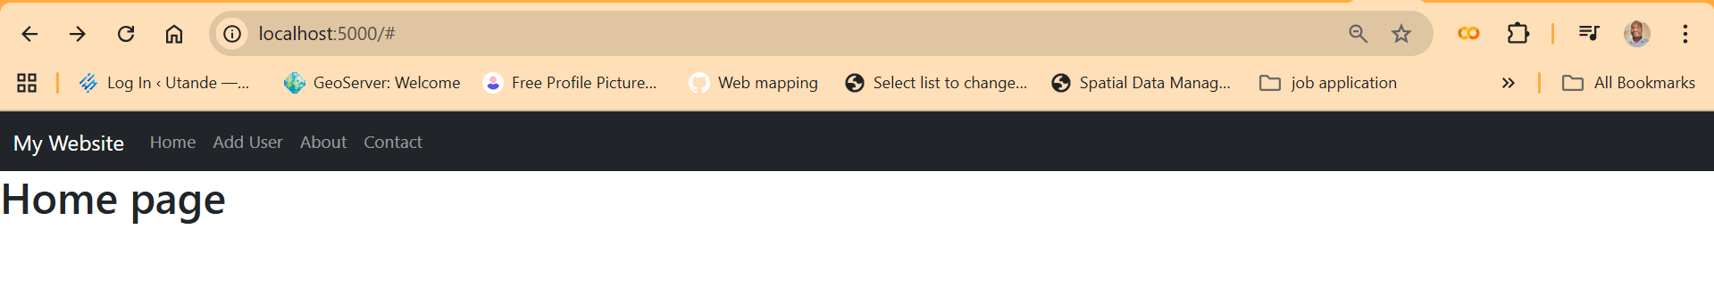

<< create a layout folder under views. Add header and footer.ejs

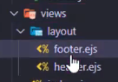

Header ejs >> cut everything until the nav section from index.ejs. Paste remaining to footer

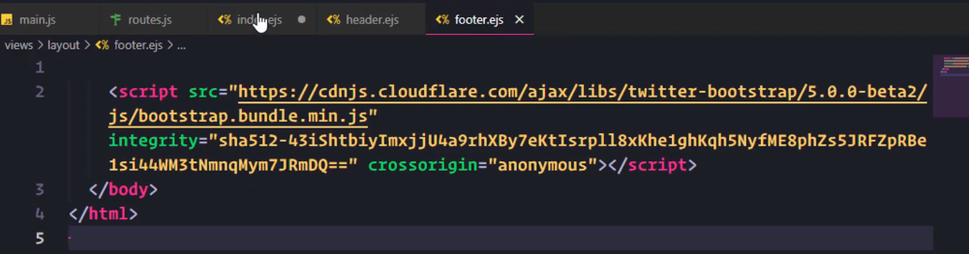

>> Link the files to index.ejs

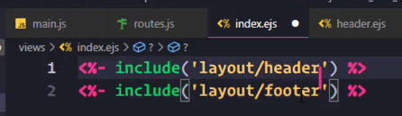

The index.ejs will continue to work

>>add a container class and add content

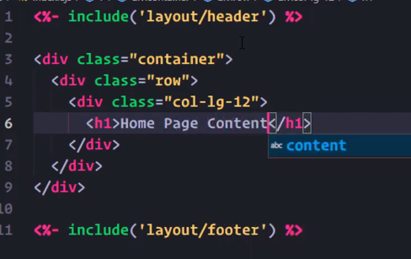

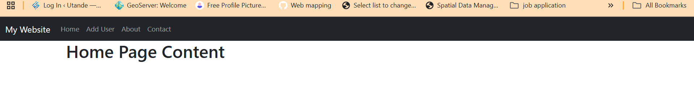

Create the route for add user



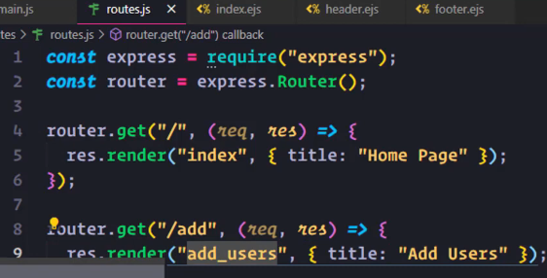

Create addusers.ejs >> test the kink on the home page

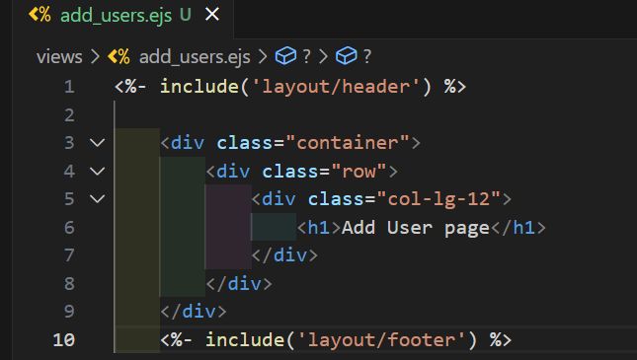

Create routes for all views

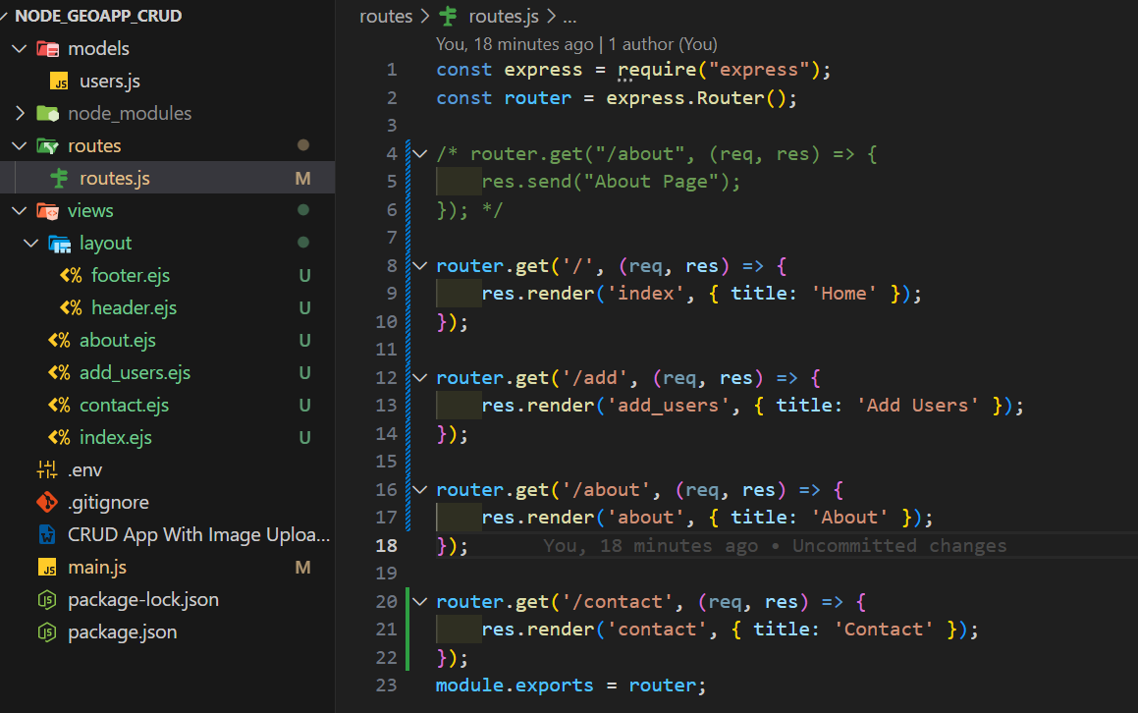

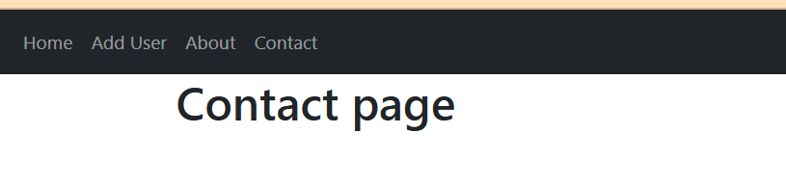

In Add users, Create a form 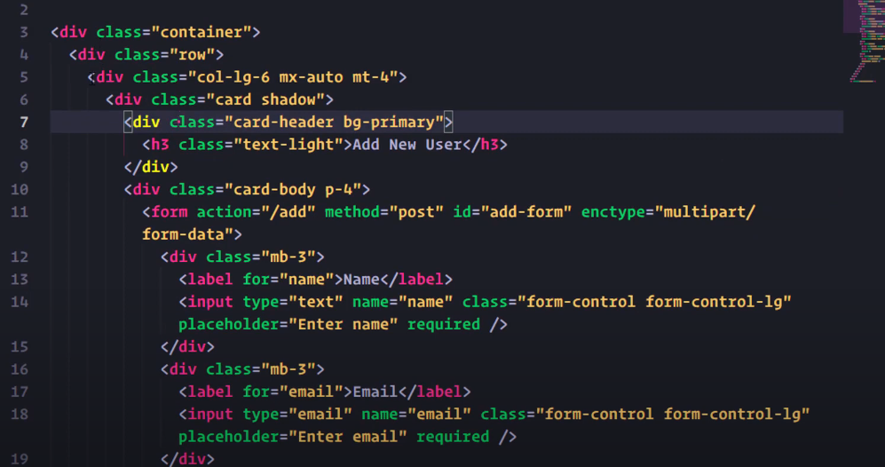

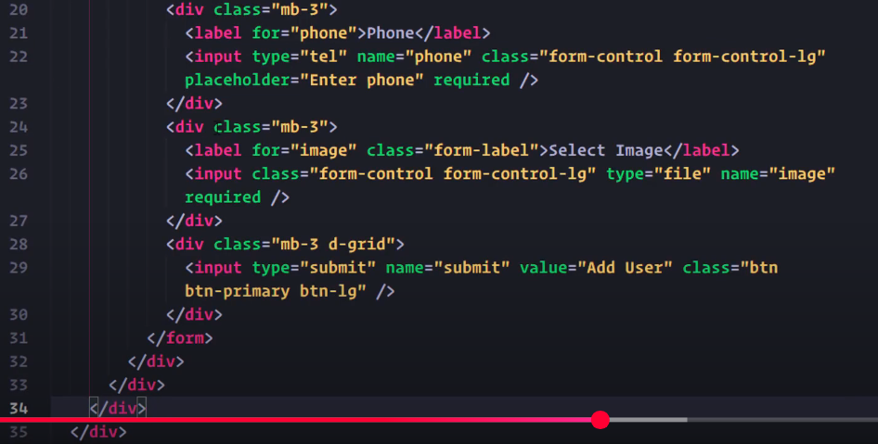

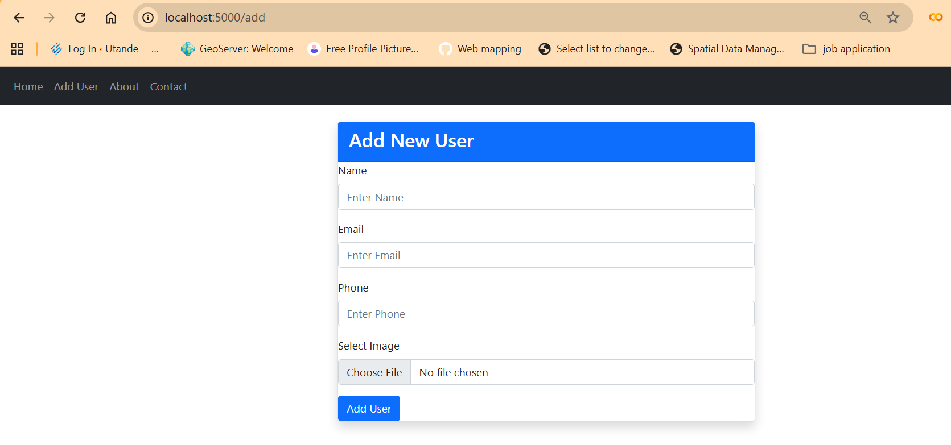

>> In home we display all datafrom the db- Edit the homepage to createa tabe to hold the output

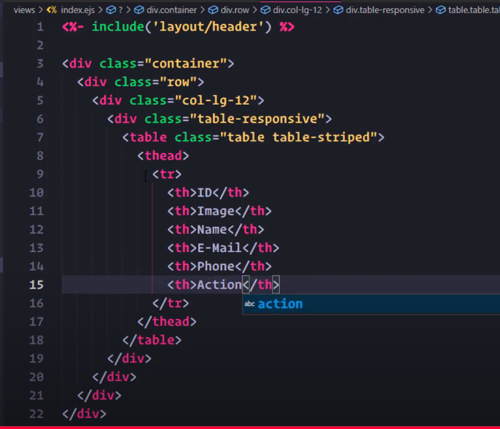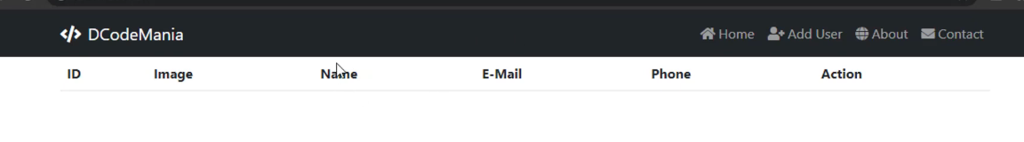

Add margin top and bottom of4



Give tr a dark theme







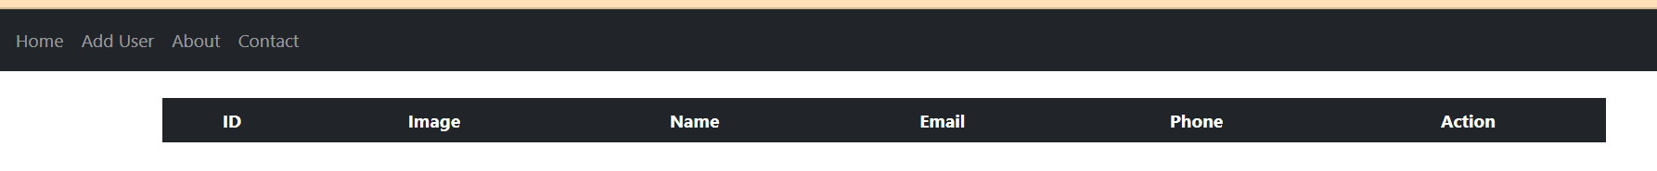

Add tbody

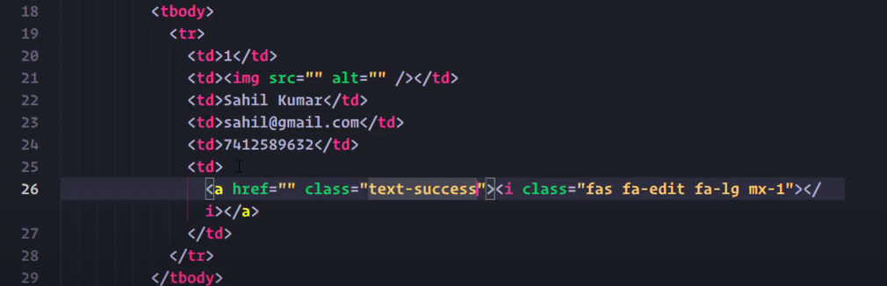

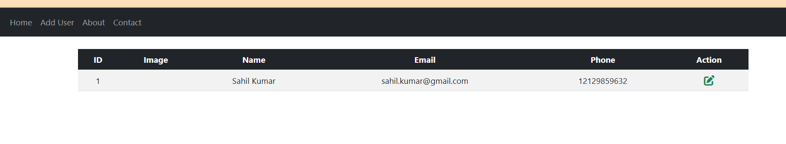

Add delete btn

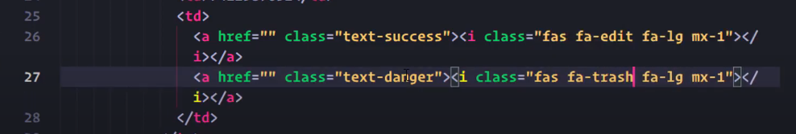



Insert records using form >> include the model to routed

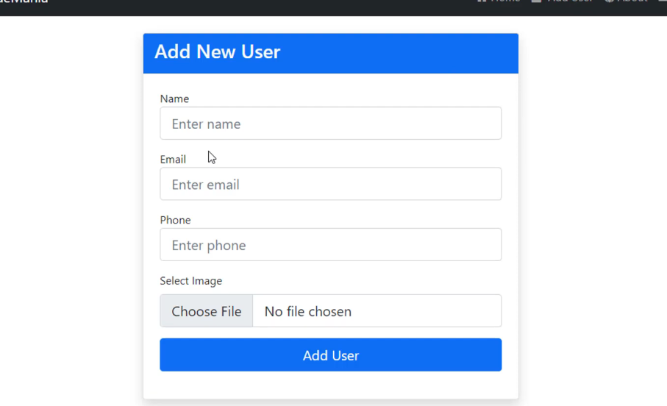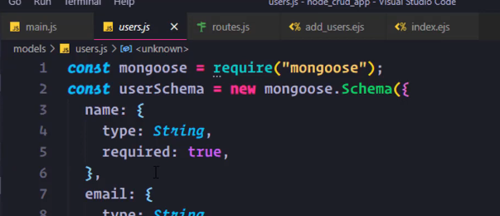

The model name is user 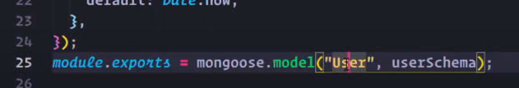

>> first import the users.ejs

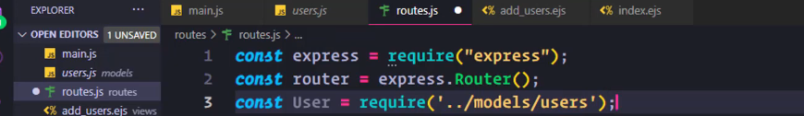

Import multer to support file upload (img, pdf, doc)

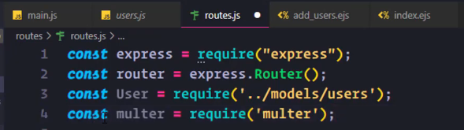

Img upload takes 3 para- requ, file and call back fn

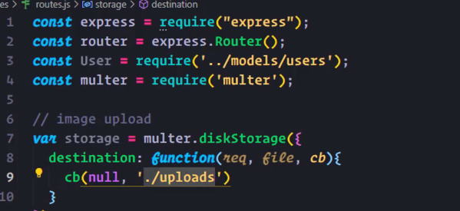

>> create the upload dir in the root to hold the files

>> define a fn to give name to the uploaded file

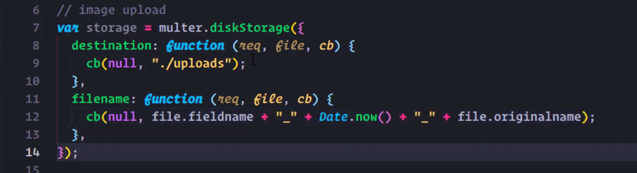

Save image >> match the name img line18



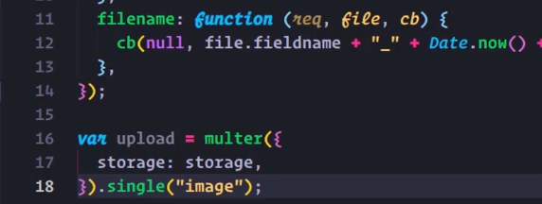

>> single cox we are uploading 1 image

>> Create a post route to add the img to a db link to /add route defined in form



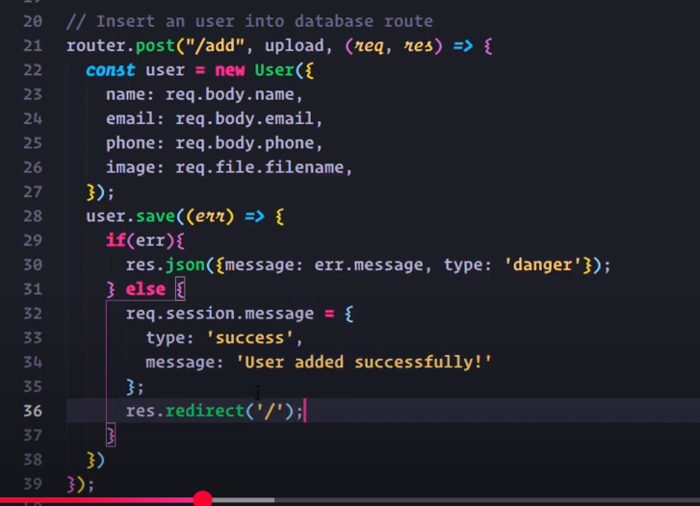

>> filename line 26 is defined in fn above

>> line 22 User is the name of the schema

>> 32 session msg defined in main.js as a middleware

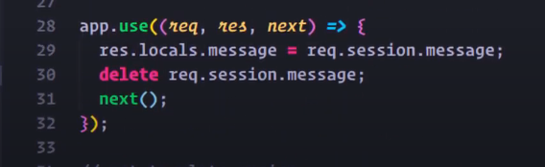

The upload fails coz the latest version of mongo doesn’t support callback – needto use asyn await

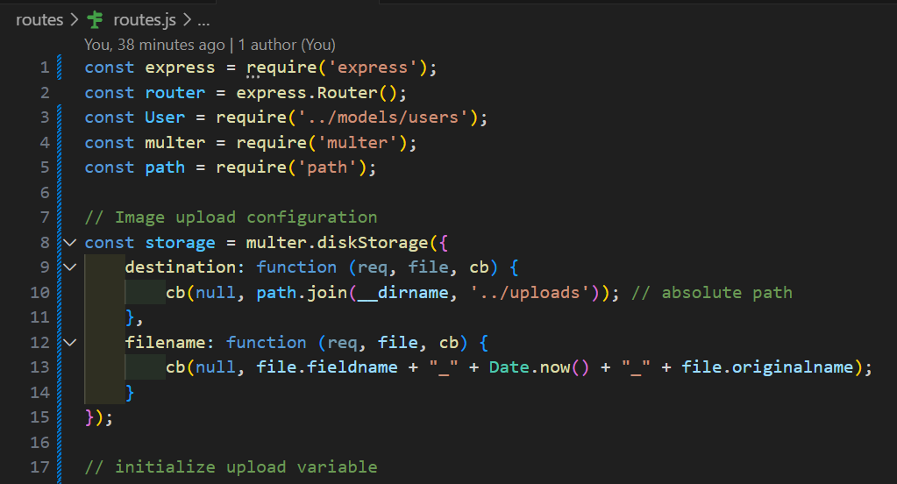

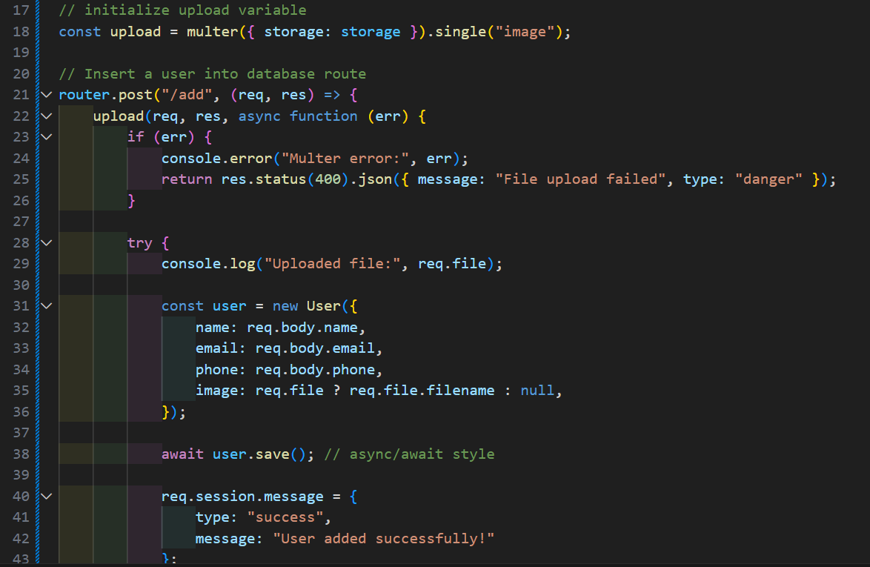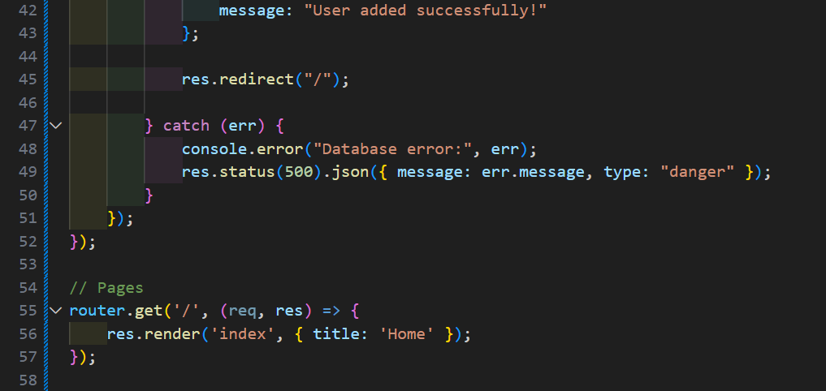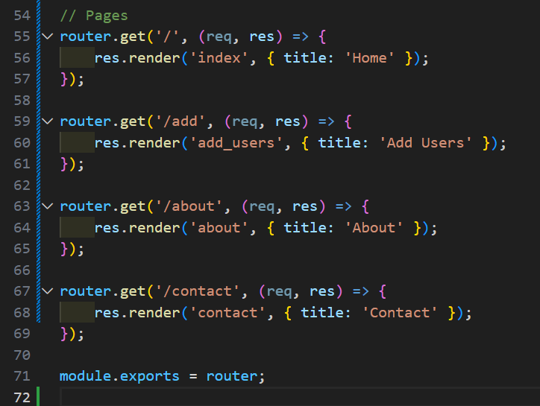

|  |
| --- |
| Code |
| 1const express = require('express');  const router = express.Router();  const User = require('../models/users');  const multer = require('multer');  const path = require('path');  // Image upload configuration  const storage = multer.diskStorage({      destination: function (req, file, cb) {          cb(null, path.join(__dirname, '../uploads')); // absolute path      },      filename: function (req, file, cb) {          cb(null, file.fieldname + "_" + Date.now() + "_" + file.originalname);      }  });  // initialize upload variable  const upload = multer({ storage: storage }).single("image");  // Insert a user into database route  router.post("/add", (req, res) => {      upload(req, res, async function (err) {          if (err) {              console.error("Multer error:", err);              return res.status(400).json({ message: "File upload failed", type: "danger" });          }          try {              console.log("Uploaded file:", req.file);              const user = new User({                  name: req.body.name,                  email: req.body.email,                  phone: req.body.phone,                  image: req.file ? req.file.filename : null,              });              await user.save(); // async/await style              req.session.message = {                  type: "success",                  message: "User added successfully!"              };              res.redirect("/");          } catch (err) {              console.error("Database error:", err);              res.status(500).json({ message: err.message, type: "danger" });          }      });  });  // Pages  router.get('/', (req, res) => {      res.render('index', { title: 'Home' });  });  router.get('/add', (req, res) => {      res.render('add_users', { title: 'Add Users' });  });  router.get('/about', (req, res) => {      res.render('about', { title: 'About' });  });  router.get('/contact', (req, res) => {      res.render('contact', { title: 'Contact' });  });  module.exports = router; |

Code with async await resuls

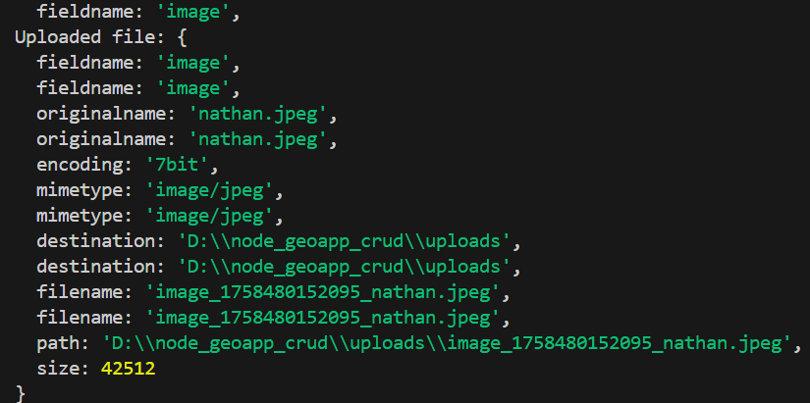

The imgs are uploaded in the uploads dir

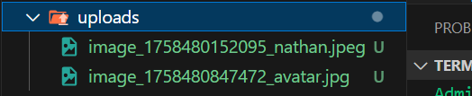

On mogooes the files are saved as documents

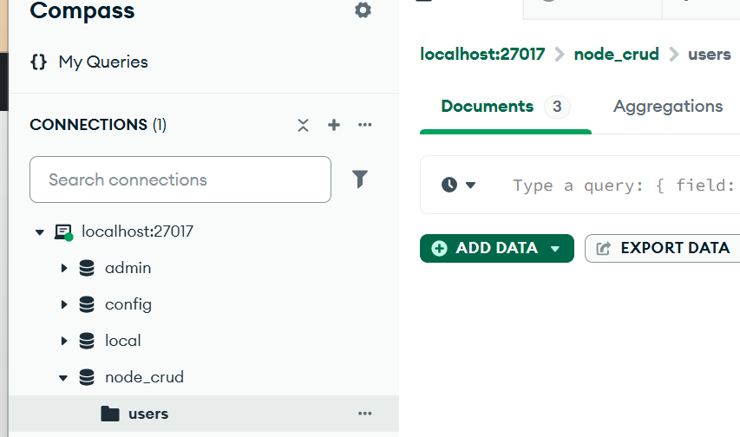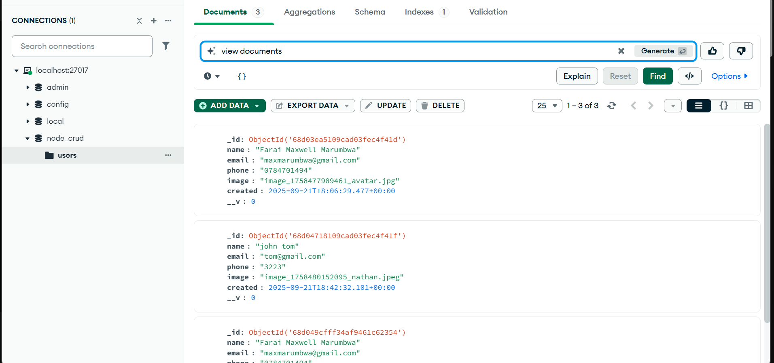

Add msg to indicate the success in upload – index.js

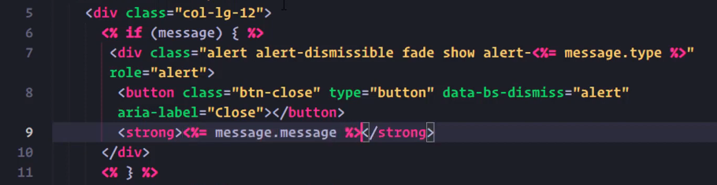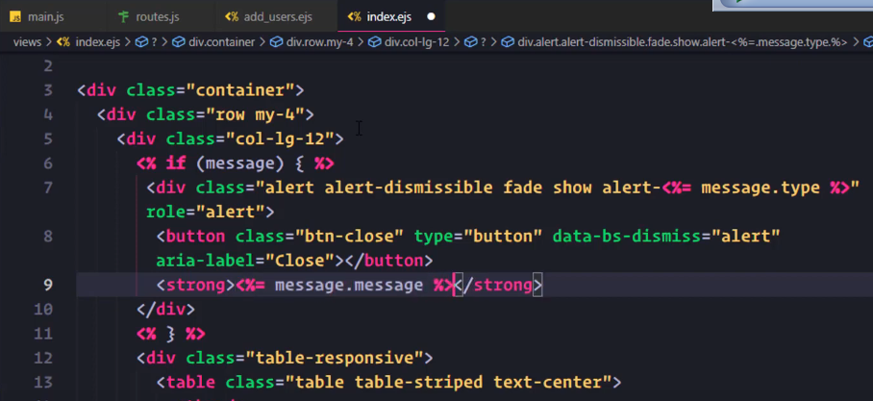

Now gets a msg printed

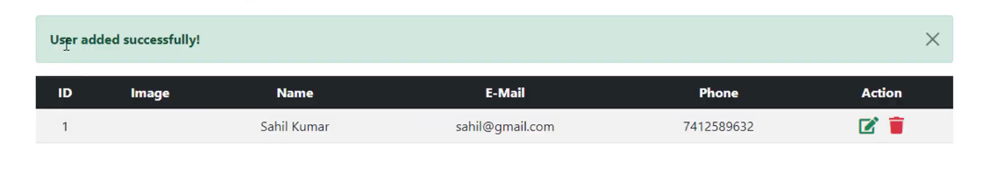

~~Create a router to visualise the data from db~~

~~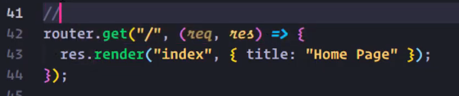~~

~~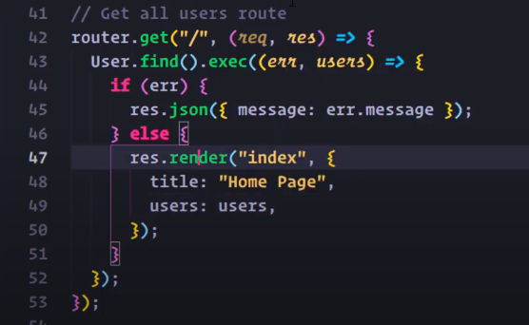~~

~~In the index.ejs replace the static vals with a loop~~

~~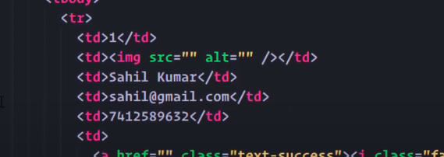~~

~~First check if users are present in the db~~

~~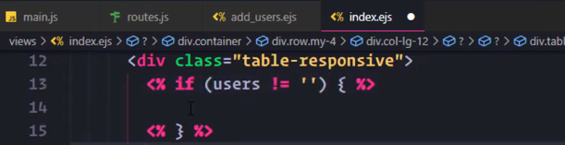~~

~~Cut and paste the table in db~~

~~~~

~~Copy the table to the if block and add else if table not found~~

~~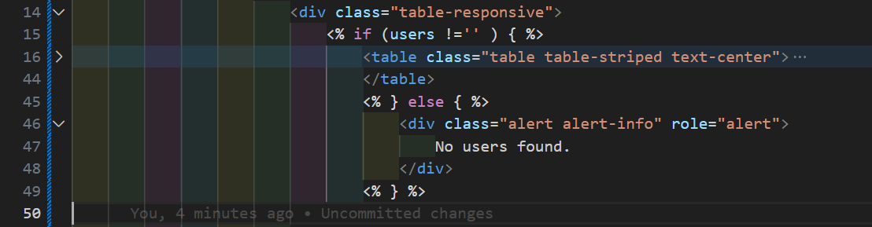~~

~~Use for each loop to display vals in the db >> delete hard coded valzin tbody~~

~~~~

~~Paste the tr tag within the forEach~~

~~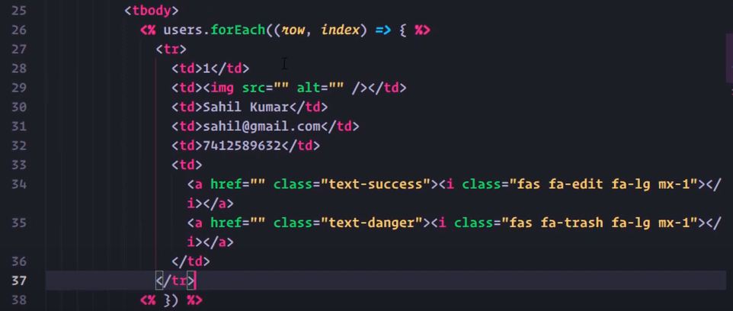~~

~~Replace the tr with variables~~

~~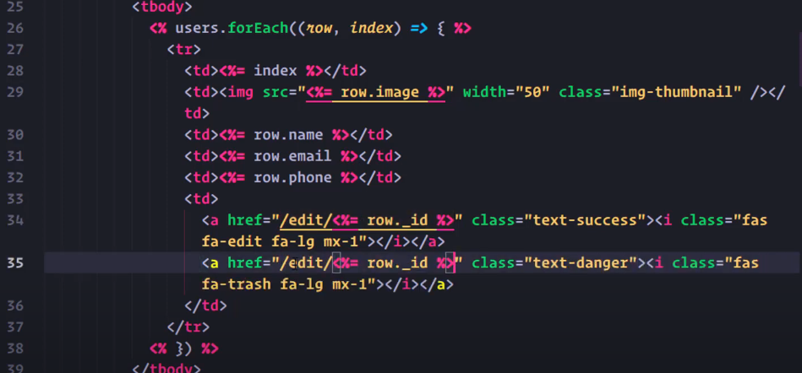~~

**THE ABOVE IN CROSS THRU not working**

Route to display data from db – all records

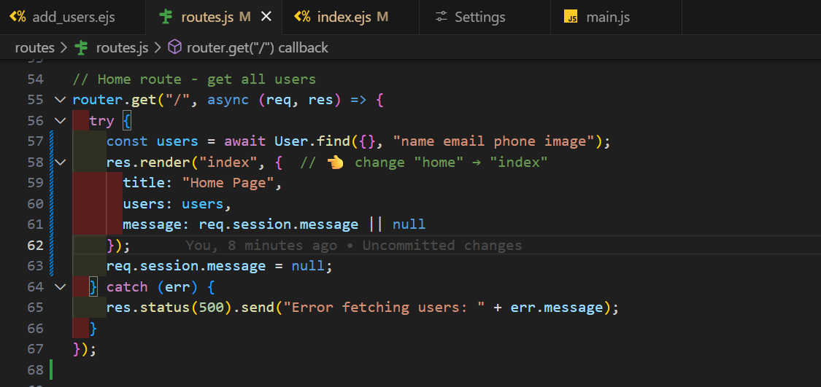

Edit the index.ejs include a loop

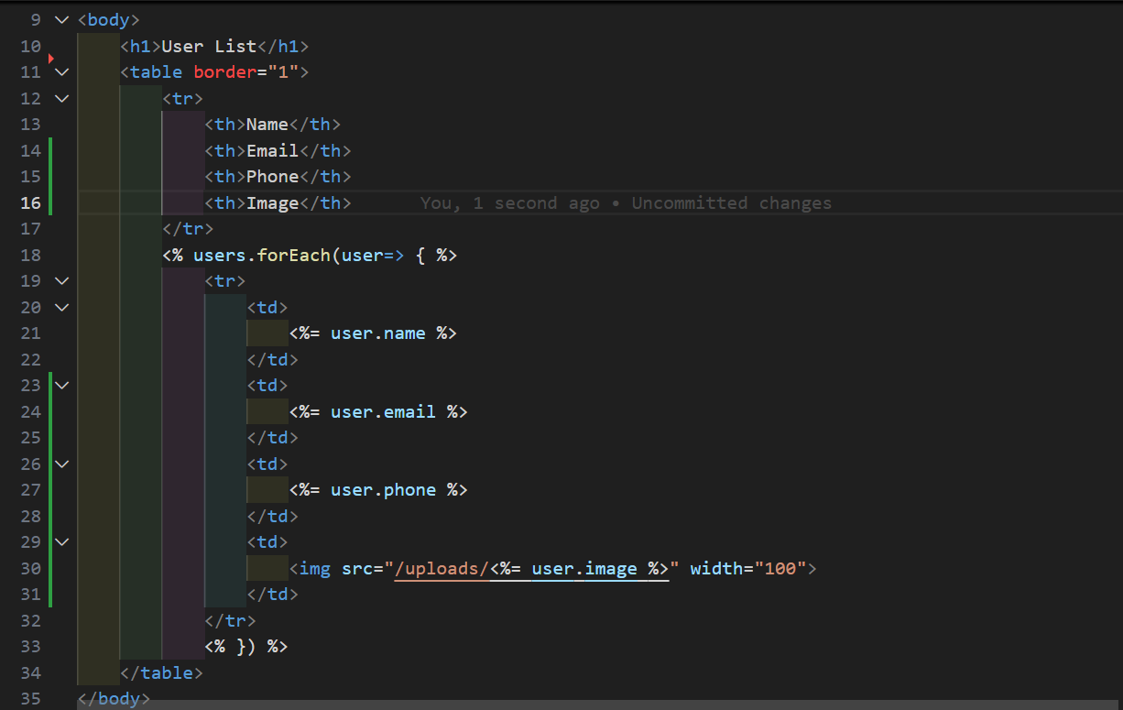

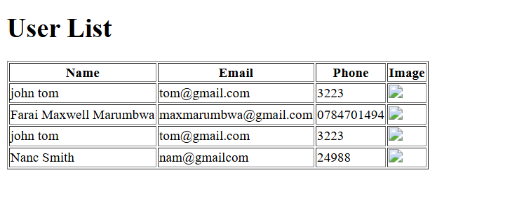

Images don’t show because the browser doesn’t know how to reach files inside your uploads/ folder unless you explicitly expose it.

